**Lab 07**

**Implementation of a 3 bit up and down counter using**

**FPGA’s source clock and Clock Divider**

**Objective:**

* To implement a BCD to Seven Segment Decoder on Spartan 6 board

**Components needed for this lab:**

* Xilinx ISE
* Spartan 6 Board

**BCD to 7-Segment Display:**

In this lab, we will take a BCD input from the user and display the corresponding number on a seven-segment display. The diagram shows the 7-bit code for displaying the digit ‘2.’ tTe enable signal must be low to activate a specific seven-segment display. The Spartan 6 board has four such displays, and later labs will cover time multiplexing techniques to control all four displays using shared input signals (A, B, C, D, E, F, G, Dp).

**Tasks**

**Implement 3-bit Up and Down Counter using RST if the RST is high it should Count Up if it is low it should Count Down and display the count in the seven segment display.**

**module** top(

clk, seg, up_down

);

**input** clk, up_down;

**output** [10:0]seg;

wire [2:0]count;

ud_counter uc(up_down, clk, count);

bcd b(count, seg);

**endmodule**

Verilog Code for Top Module

**module** ud_counter(

**input** up_down, **input** clk, **output** [2:0]count

);

reg [2:0]count = 3'b0000;

wire clk_out;

Clock_divider(clk, clk_out);

**always** @(**posedge** clk_out)

**if**(up_down)

count = count + 1;

**else**

count = count - 1;

**endmodule**

Verilog Code for Up Down Counter

**module** bcd(

**input** [2:0]count, **output** [10:0]seg

);

reg [10:0]seg;

**always**@(*)

**case**({1'b0, count})

4'd0: seg = 11'b10000000011;

4'd1: seg = 11'b11110010011;

4'd2: seg = 11'b01001000011;

4'd3: seg = 11'b01100000011;

4'd4: seg = 11'b00110010011;

4'd5: seg = 11'b00100100011;

4'd6: seg = 11'b00000100011;

4'd7: seg = 11'b11110000011;

**default**: seg = 11'b10000000011;

**endcase**

**endmodule**

Verilog Code for 7-Segment BCD

**module** Clock_divider(clock_in,clock_out

);

**input** clock_in; *// input clock on FPGA*

**output** reg clock_out; *// output clock after dividing the input clock by divisor*

reg[27:0] counter=28'd0;

**parameter** DIVISOR = 28'd20000000000;

*// The frequency of the output clk_out*

*// = The frequency of the input clk_in divided by DIVISOR*

*// For example: Fclk_in = 50Mhz, if you want to get 1Hz signal to blink LEDs*

*// You will modify the DIVISOR parameter value to 28'd50.000.000*

*// Then the frequency of the output clk_out = 50Mhz/50.000.000 = 1Hz*

**always** @(**posedge** clock_in)

**begin**

counter <= counter + 28'd1;

**if**(counter>=(DIVISOR-1))

counter <= 28'd0;

clock_out <= (counter<DIVISOR/2)?1'b1:1'b0;

**end**

**endmodule**

Verilog Code for Clock Divider

# PlanAhead Generated physical constraints

NET "seg[4]" LOC = A3;

NET "seg[5]" LOC = B4;

NET "seg[6]" LOC = A4;

NET "seg[7]" LOC = C4;

NET "seg[8]" LOC = C5;

NET "seg[9]" LOC = D6;

NET "seg[10]" LOC = C6;

NET "seg[3]" LOC = A5;

NET "seg[2]" LOC = B3;

NET "seg[1]" LOC = A2;

NET "seg[0]" LOC = B2;

NET "up_down" LOC = C17;

# PlanAhead Generated IO constraints

NET "clk" PULLUP;

NET "seg[10]" SLEW = FAST;

NET "seg[9]" SLEW = FAST;

NET "seg[8]" SLEW = FAST;

NET "seg[7]" SLEW = FAST;

NET "seg[6]" SLEW = FAST;

NET "seg[5]" SLEW = FAST;

NET "seg[4]" SLEW = FAST;

NET "seg[3]" SLEW = FAST;

NET "seg[2]" SLEW = FAST;

NET "seg[1]" SLEW = FAST;

NET "seg[0]" SLEW = FAST;

NET "up_down" PULLUP;

# PlanAhead Generated physical constraints

INST "clk_BUFGP" LOC = V10;

NET "clk" LOC = V10;

UCF File Code fo Top Module

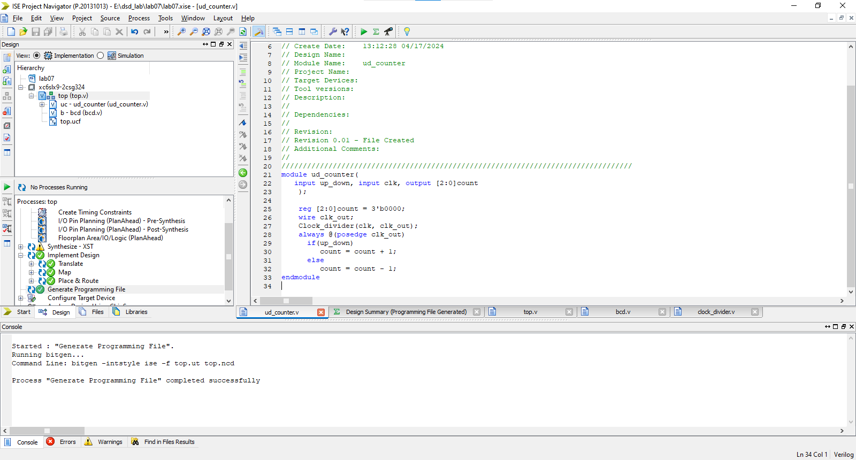

Fig 02: All Modules in run in the Xilinx ISE

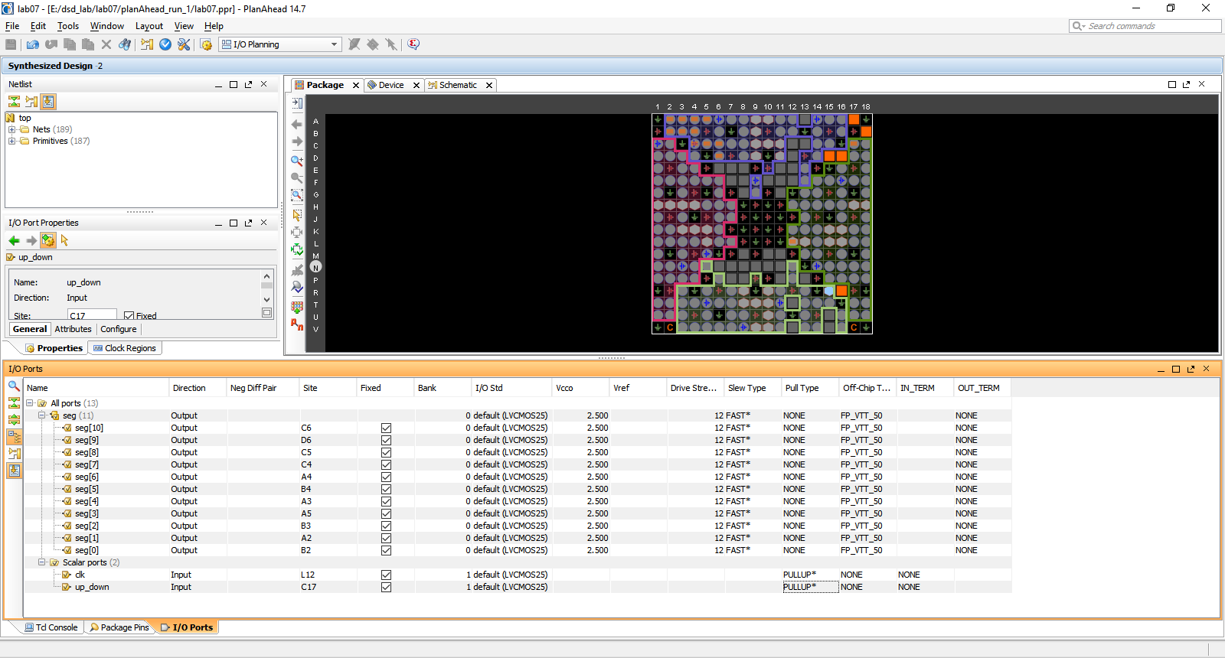Fig 03: Choosing input and output ports for spartan 6 board

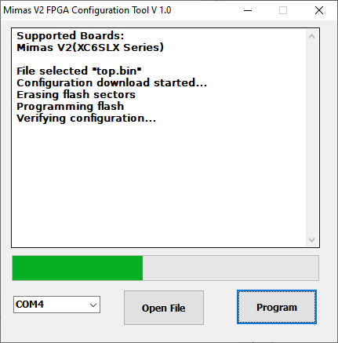

Fig 04: Programming Spartan 6 board with .bin file

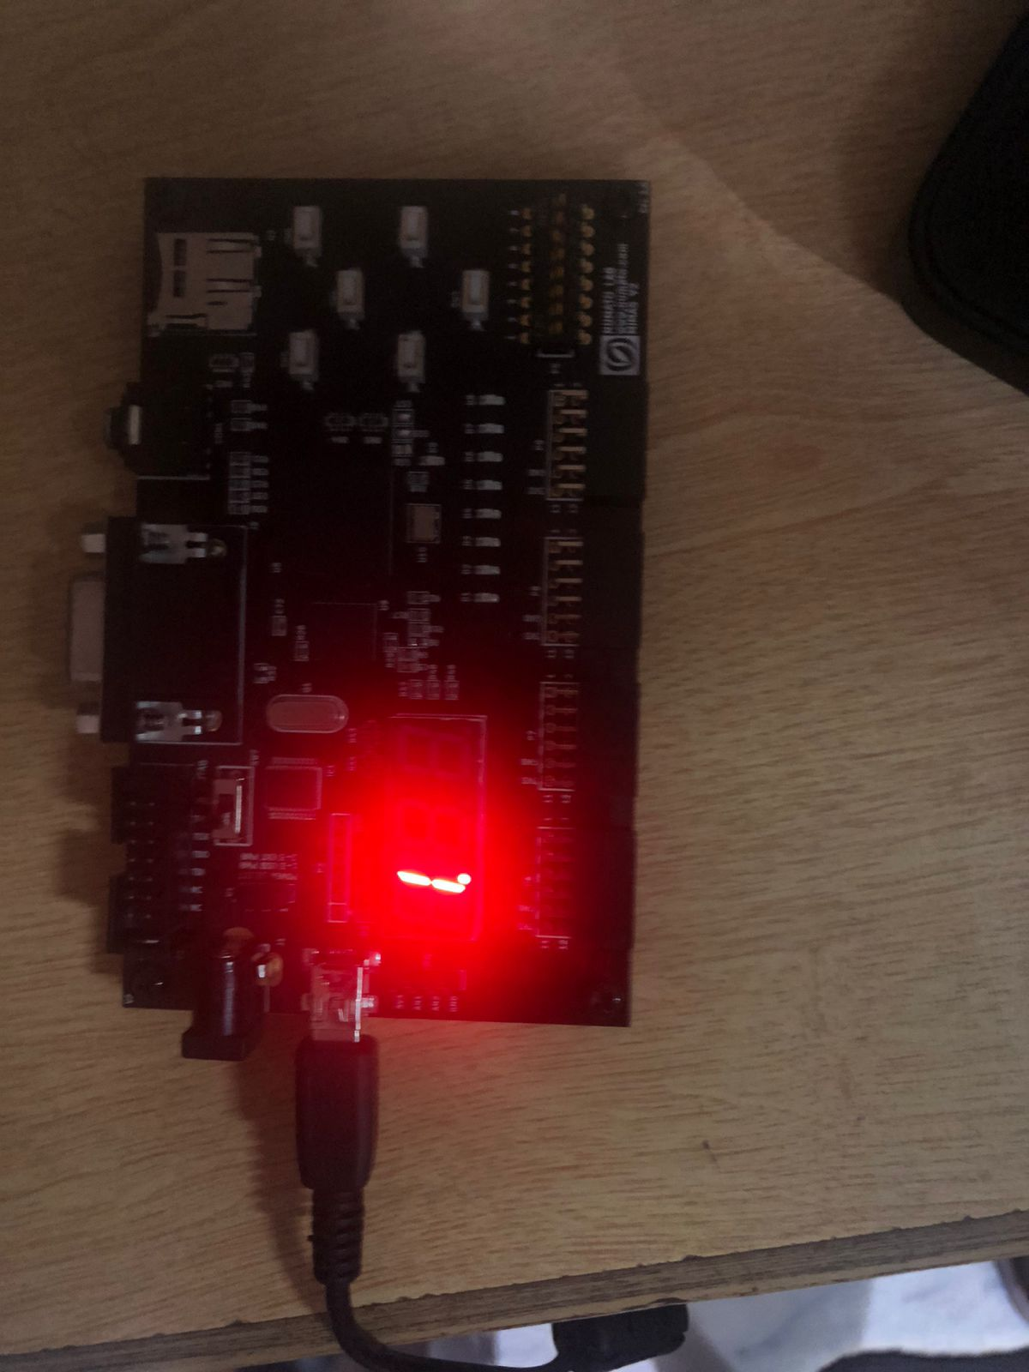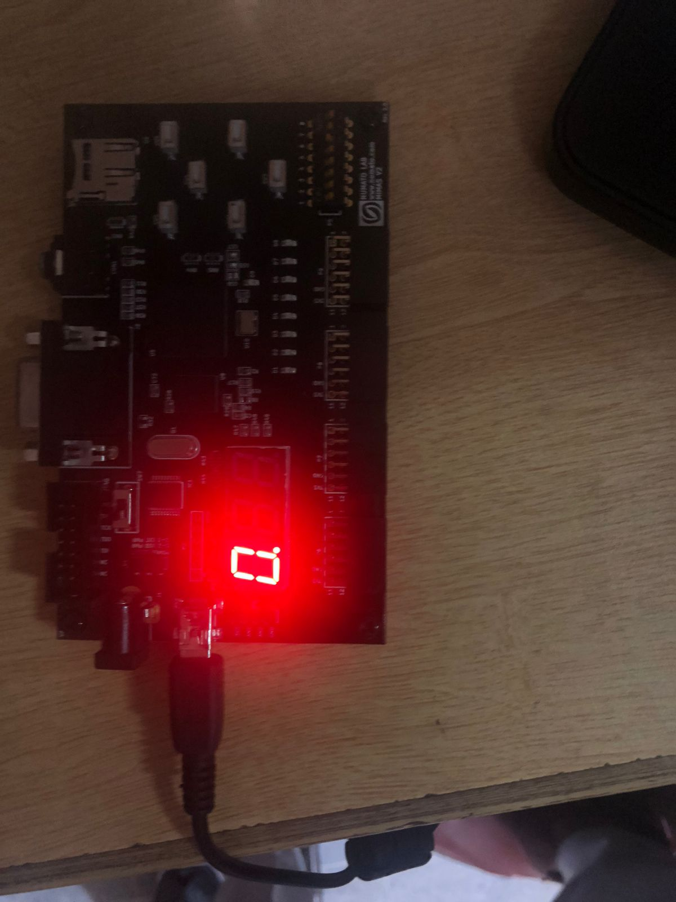

Fig 05: BCD Displaying 0

Fig 06: BCD displaying 1

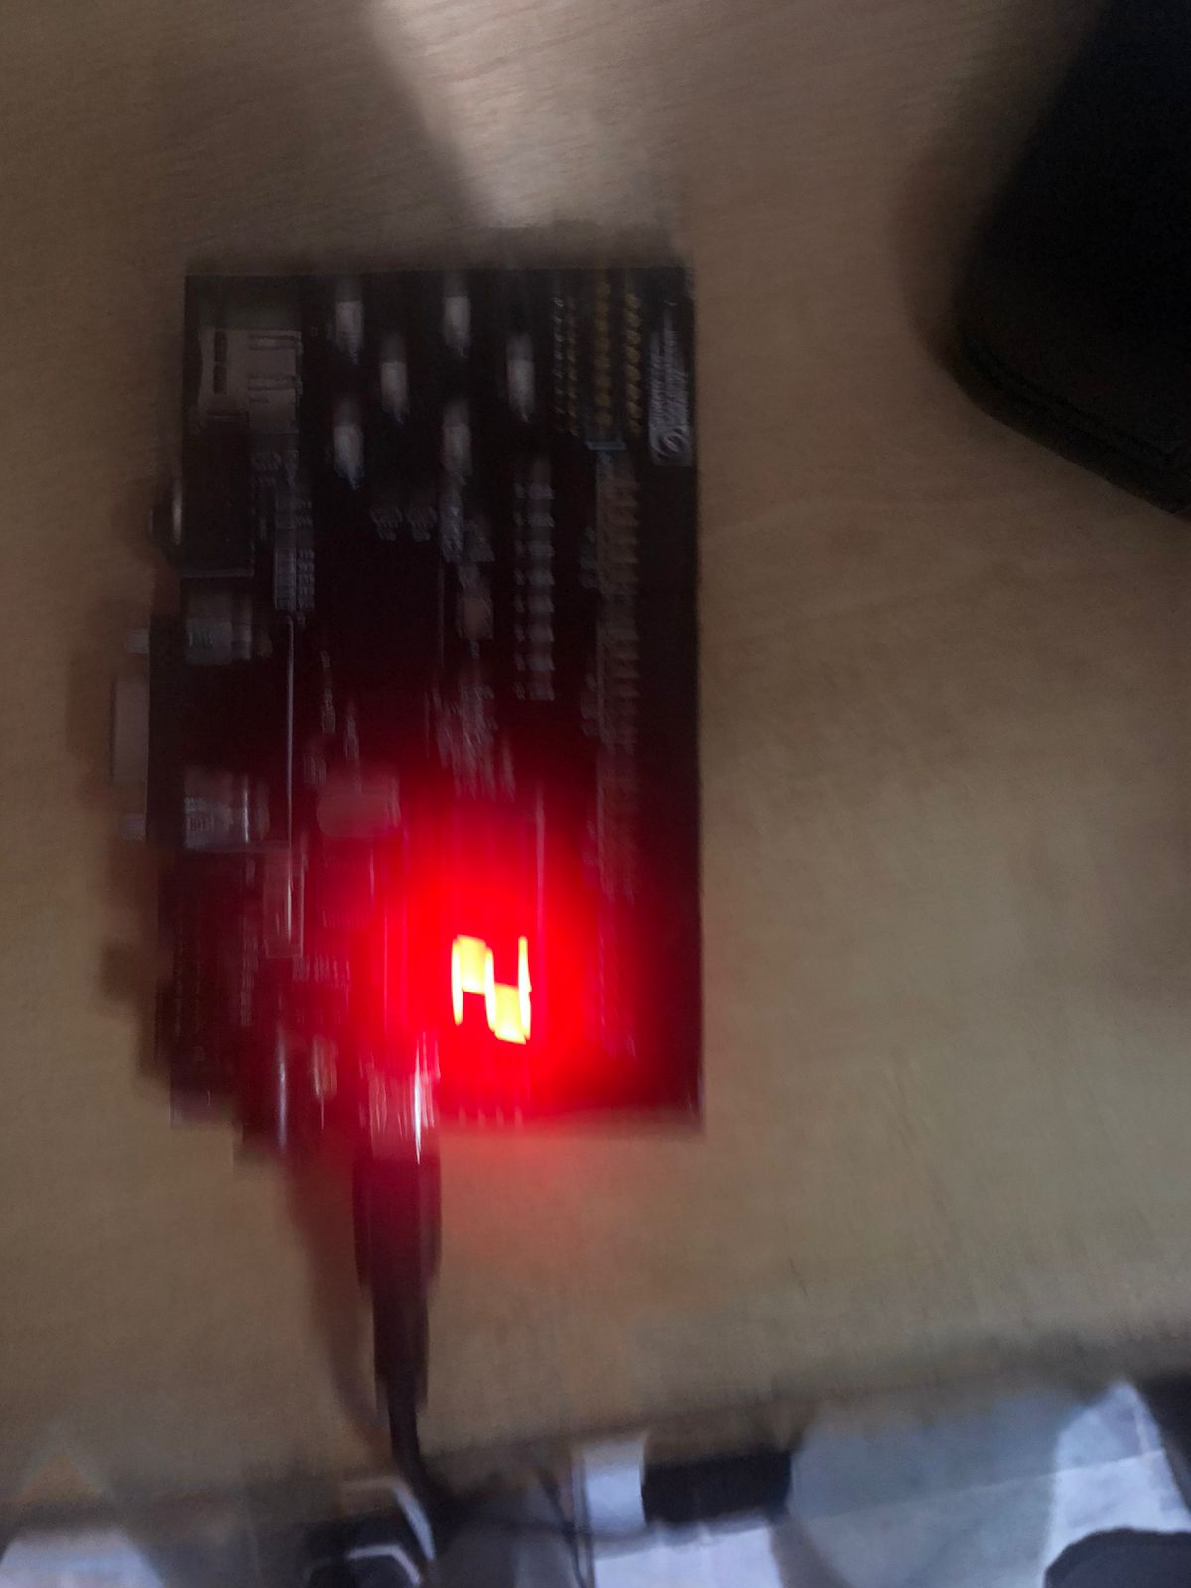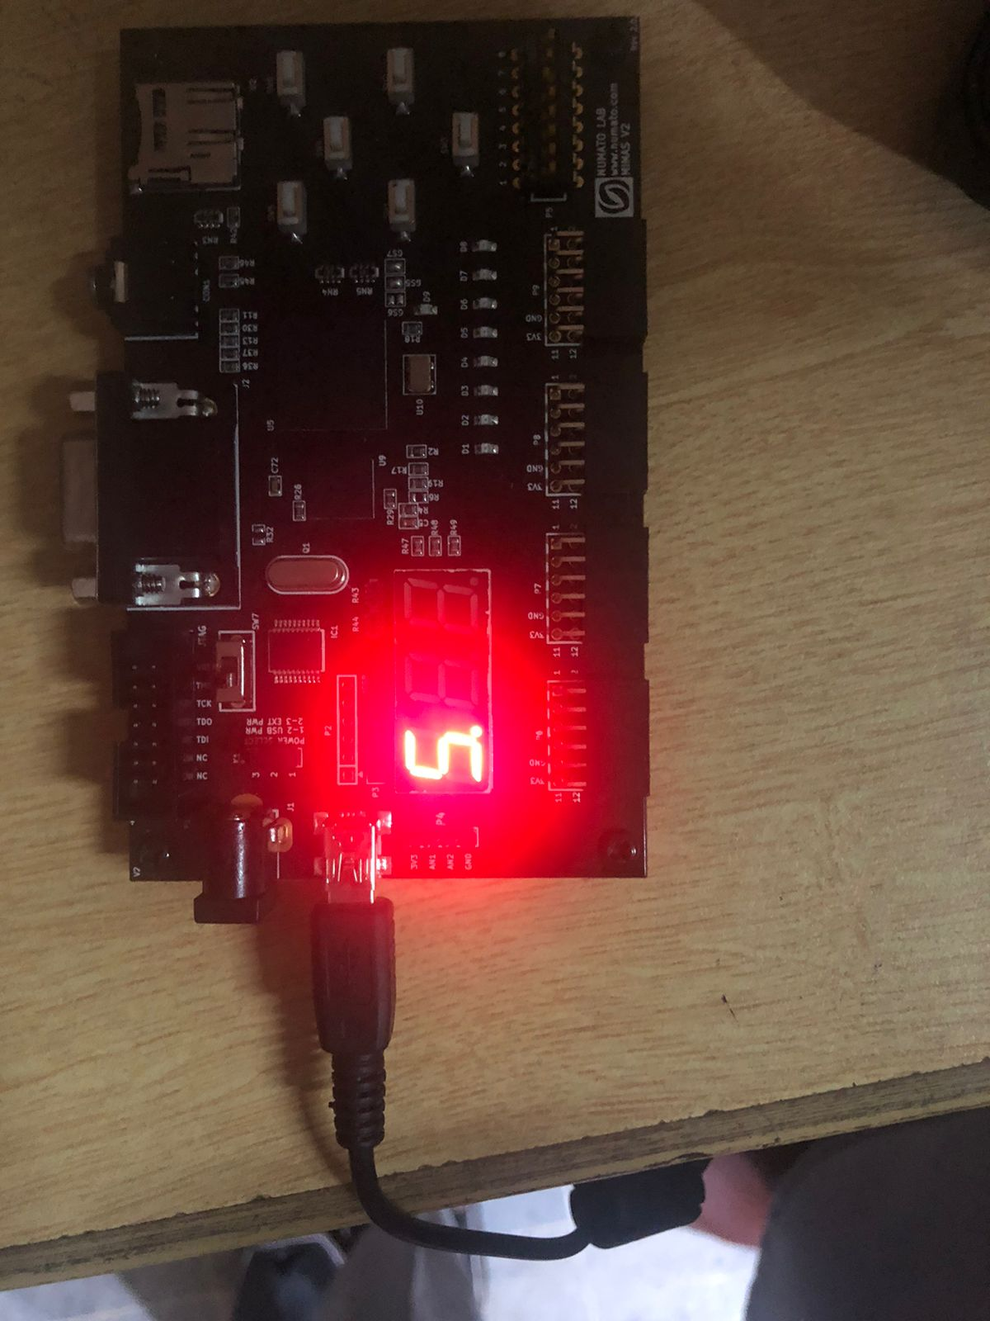

Fig 07: BCD displaying 2

Fig 08: BCD displaying 5

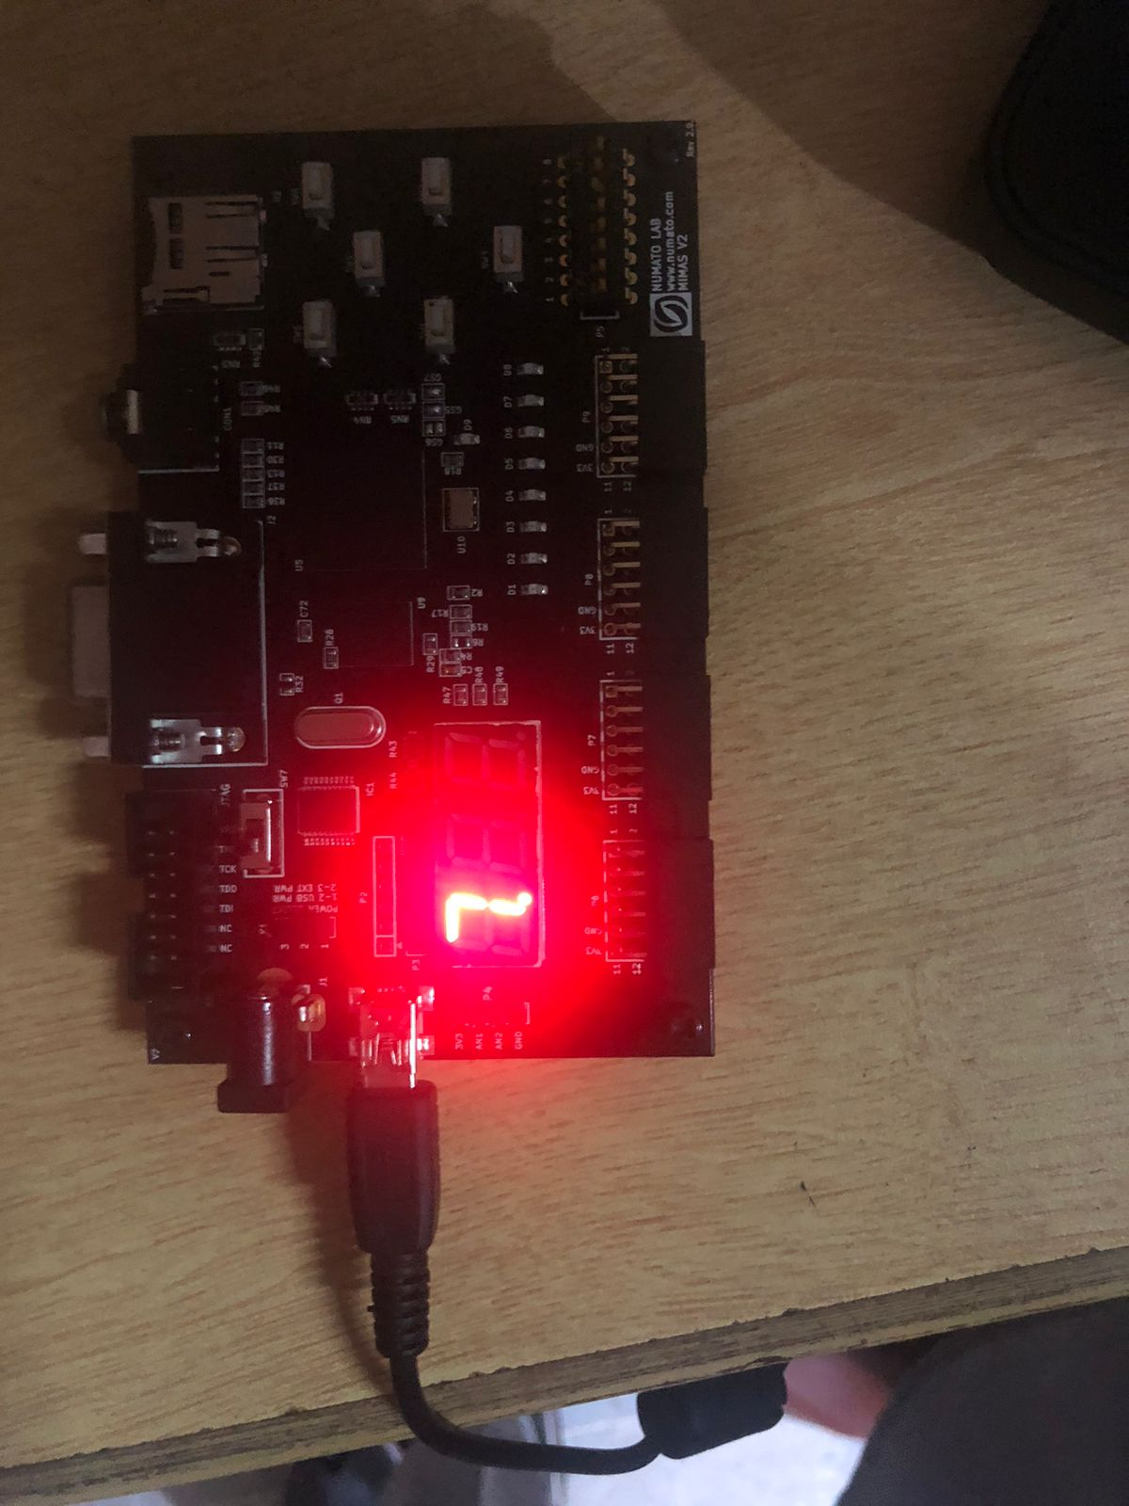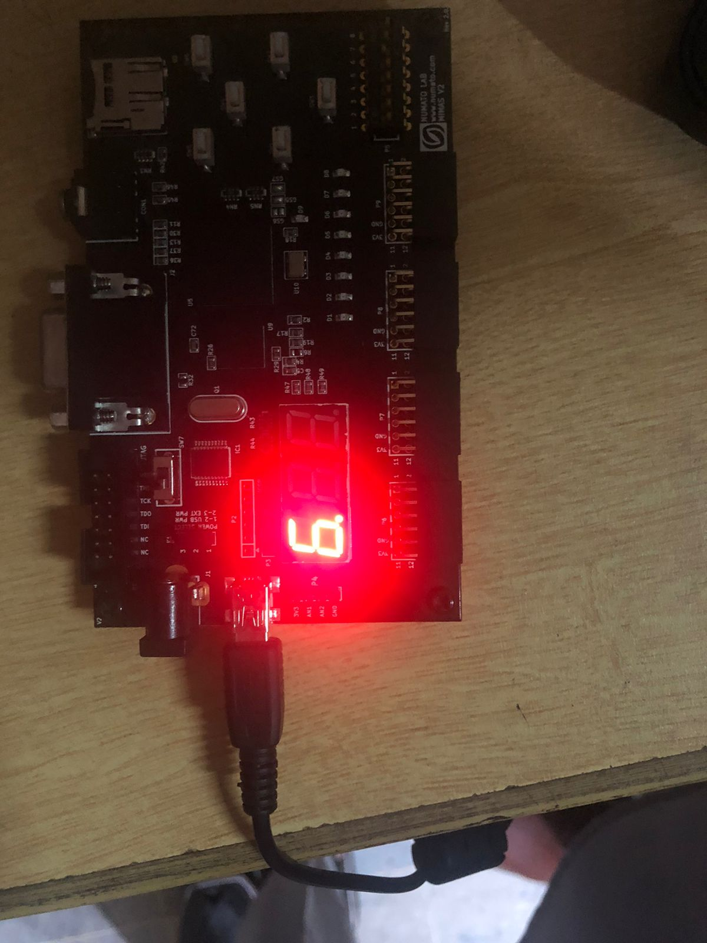

Fig 09: BCD displaying 7

Fig 10: BCD goes upto 9

**Conclusion:**

In this Lab we learned divide the clock frequency to slow down the counting and we created an up down counter and connected it’s output to the BCD display by enabling only one of them.

**____________________________________________________________________________________________________________________________**